**Abstract for Python Project**

**Introduction**

We are planning to create a simple camera based application where the commands are given by our hand gestures. Basically we will use image processing features to give commands to play a simple game .

**Libraries Used**

For image processing we will be using OpenCV, Mediapipe and Pygame to guess hand gestures and some other modules.

**An Imagination of Project**

We will first learn the basics of OpenCV to connect a hand gesture to a specific key on the keyboard followed by the creation of the gaming interface. An estimated time of at least 2 weeks will be required.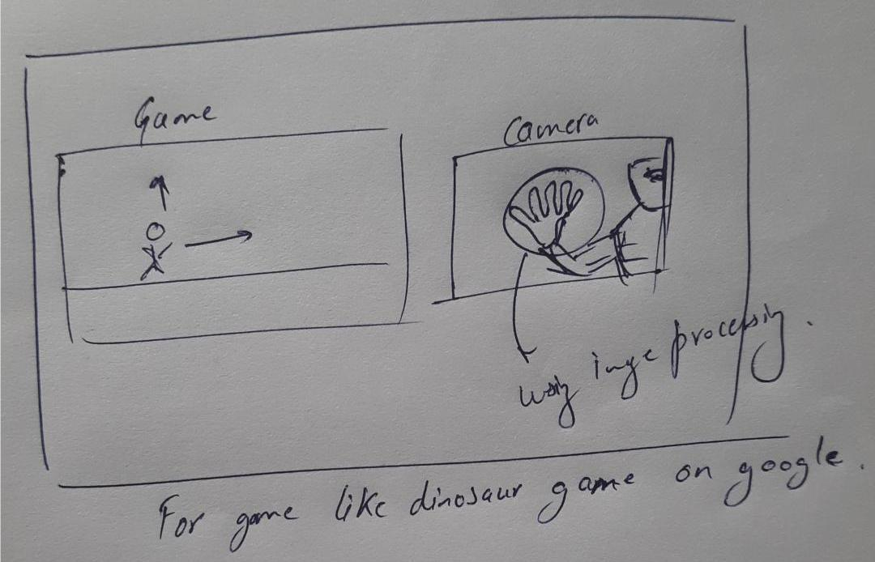

**Timeline**

**26th to 30th June** - Learning to use the OpenCV library and the basics concepts of Image Processing.

**1st to 4th July** - Writing the code for mapping hand gestures

**5th to 9th** - Developing the game and the gaming interface

**10th to 12th** - Enhancing the program, making sure we wrote the code in the most efficient/pythonic way possible. Testing the game and Debugging if required.

**Motivation**

This is the first project we are doing using Python. We both are interested in Image Processing and Game Development. Therefore we felt that it would be a good start for us to create a project requiring both these skills.

**References**

PyCK Course Lectures and Notes

ER101 Lectures and Notes based on image processing using OpenCV (Electronics and Robotics Club, IIT Bombay)

Youtube.